Mobile Platform v1.0.0
Developer's Guide

17 November 2009

Introduction
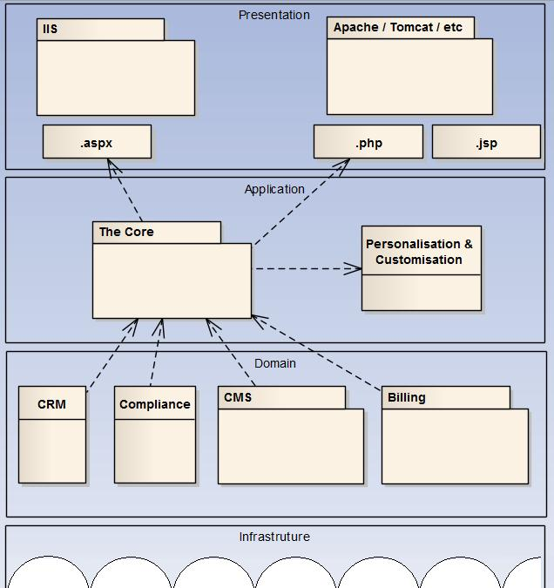Figure 1: Layered architecture & component layout
This document forms part of The Core software development kit.

Document structure

Audience
This document is written for technical people who want to use or understand the Korwe integration platform

Comments and feedback
Please contact Korwe at admin@korwe.com if with any comments or questions.

Licensing
TBD

Architecture
The platform provides and application layer integration platform for mobile as shown in Figure 1. The intention of the platform is to consolidate and control of information flow to one place, the platform. At this central location, application logic can be applied for personalisation and customisation.

Getting Started

Sending messages
Read through TestClient.cpp code to see how messages are sent. The program is functional and can be run under CentOS. It will write success and failure messages to the console.

Receiving messages
Read through TestServer.cpp code to see how messages are received. The program is functional and can be run under CentOS. It will write success and failure messages to the console.

Figure 2 is a simple illustration of sending and receiving Core messages.

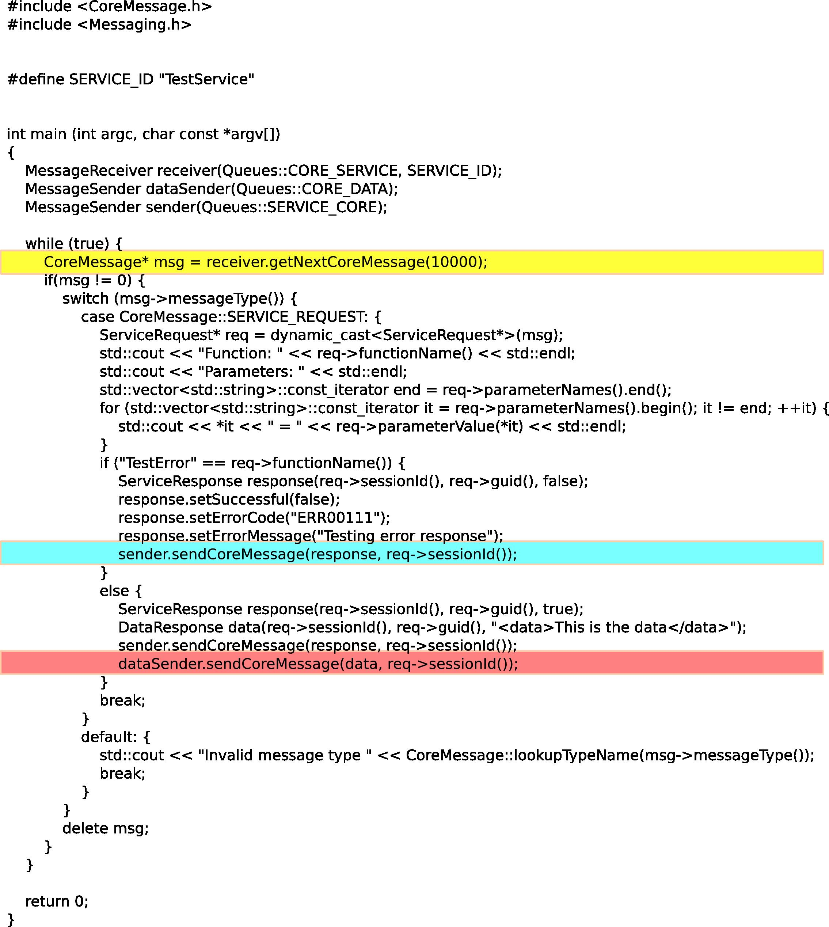Figure 2: Send and Receive Code examples
C++:
MessageSender sender(Q_SERVER, Queues::CLIENT_CORE);
MessageReceiver receiver(Q_SERVER, Queues::CORE_CLIENT, SESSION_ID);
sender.sendCoreMessage(InitiateSessionRequest(SESSION_ID), SESSION_ID);
InitiateSessionResponse* response =
dynamic_cast<InitiateSessionResponse*>(receiver.getNextCoreMessage(500));
if (response == 0) {
std::cout << "No response to initiate session" << std::endl;
return 1;
}
else {
std::cout << "Received initiate session response" << std::endl;
std::cout << "Session initiation " << (response->isSuccessful() ?
"was " : "was not ") << "successful" << std::endl;
}
delete response;

C#:
var sender = new CoreSender(queueServer, Queues.Queue.ClientToCore);
var receiver = new ReceiveBuffer(queueServer, Queues.Queue.CoreToClient,
sessionId);
receiver.start();
var init = new InitiateSessionRequest(sessionId);
sender.sendMessage(init);
Thread.Sleep(500);
if (receiver.ContainsKey(init.Guid)) {
CoreMessage msg = receiver.getFirstMessage(init.Guid);
var initResponse = msg as InitiateSessionResponse;
Console.Out.WriteLine("initResponse = {0}", initResponse);
bool success = initResponse.Successful;
}

The Core API

API Overview
The Core provides a message based API. It uses AMQP as its underlying messaging standard, on which it builds a specialized XML message protocol that is optimised for application level integration for mobile technologies and standards.
Figure 3 indicates the conceptual location of The Core APIs.
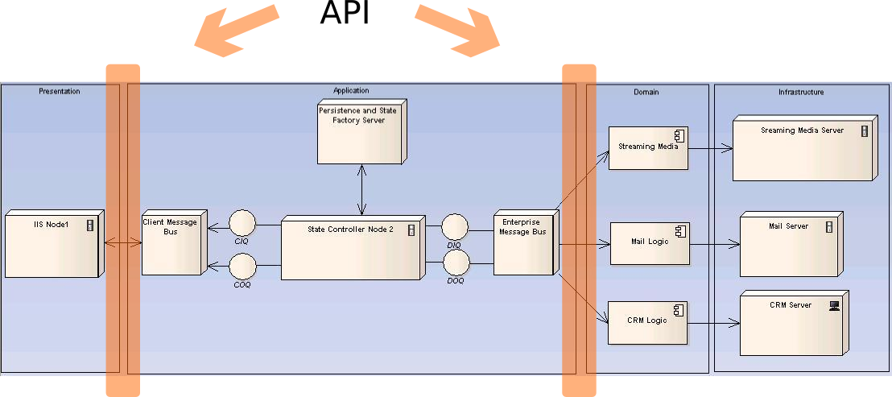Figure 3: API Location

Messaging API
There are currently C++, C# and Java libraries for interfacing with The Core, as well as a REST-style web service API.
All messages inherit from CoreMessage and at the highest level are divided between request and response messages.

Client and Service Applications
The Core distinguishes between client and service applications. Client applications are applications that request services and data from service applications and services respond to requests from clients. In other words client applications send ServiceRequest messages and receive ServiceResponse and DataResponse messages, while service applications receive ServiceRequest messages and send ServiceResponse and DataResponse messages. Clients are required to create a Core session before sending any service requests and to end it when they are done. There is no reason why a single application cannot act as both client and service, e.g., one service may require information from another.
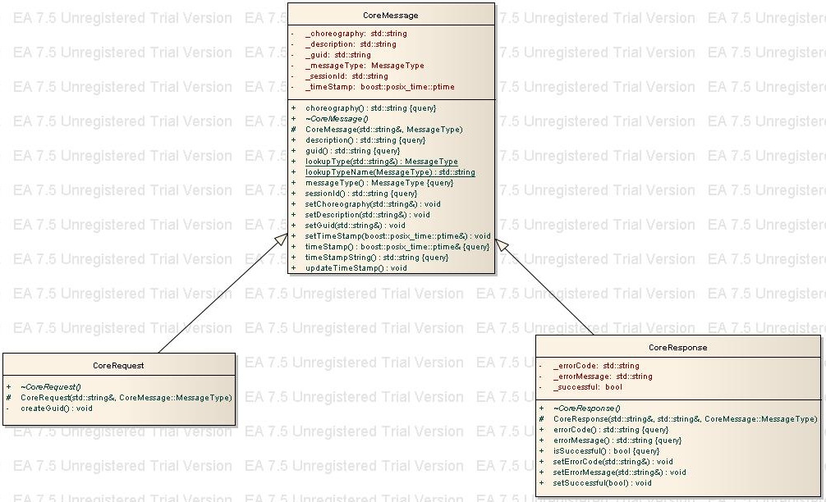
Figure 4: Base message types
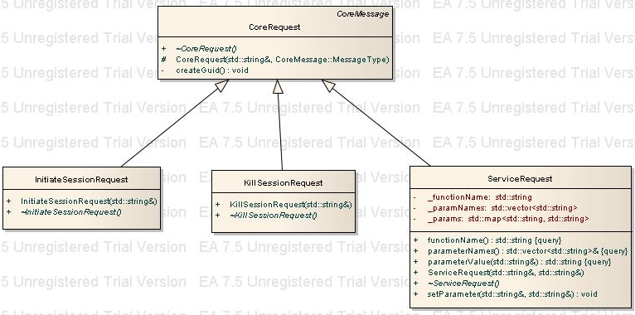Figure 5: Core Request message types

Request Messages
Request messages are usually sent by client applications. Requests are processed by The Core and may be forwarded to service applications for further processing. Each request contains a client-specified SessionId, which identifies the client session and a system-generated GUID, which identifies the request and can be used to correlate with matching responses.
There are 3 types of requests: InitiateSessionRequest, KillSessionRequest and ServiceRequest. InitiateSessionRequest establishes a client session within The Core while KillSessionRequest ends the session. While a session is active, a client may send any number of ServiceRequests, which will ultimately be processed by a service application. Every request should result in a response message being sent back to the client.

Response Messages
Response messages are sent either by The Core or by a service application. Each response corresponds to a request message and contains the same SessionId and GUID.
InitiateSessionResponse and KillSessionResponse messages are sent by The Core itself, while ServiceResponse and DataResponse are sent by service applications. DataResponse messages contain the actual data resulting from a service request. The ServiceResponse itself contains only an indication of success or failure and whether or not there is a DataResponse. This allows the Core to handle only control messages and allows data to be sent on an independent channel.
Figure 6: Core Response Message Types

Sending and Receiving Messages
The API contains a few classes to deal with sending and receiving Core messages. The sender class is instantiated with a queue server name and a queue name (see Figure 2) and sends all messages to that queue on that server. Serialization of the message object into XML is handled by the system.
The receiver classes are instantiated with a queue server and queue name as well as an identifier which identifies the client or service application for which you want to receive messages. In the case of a client application, this is the session id, and for a service application, it should be the service name.
The following table describes the queue conventions:
Client Applications |  | Service Applications
Send | Receive | Send | Receive
ClientToCore  CLIENT_CORE | CoreToClient  CORE_CLIENT | ServiceToCore  SERVICE_CORE | CoreToService  CORE_SERVICE
ClientToCore  CLIENT_CORE | Data  CORE_DATA | Data  CORE_DATA | CoreToService  CORE_SERVICE

XML Schema
The following is a basic schema for Core XML messages. The XML is usually abstracted away by the message types, but can be useful for message tracing and debugging.
<?xml version="1.0" encoding="UTF-8"?>
<xs:schema attributeFormDefault="unqualified"
elementFormDefault="qualified"
xmlns:xs="http://www.w3.org/2001/XMLSchema">
<xs:element name="coreMessage">
<xs:complexType>
<xs:sequence>
<xs:element ref="sessionId" minOccurs="1"/>
<xs:element ref="guid" minOccurs="1"/>
<xs:element ref="messageType" minOccurs="1"/>
<xs:element ref="timeStamp" minOccurs="1"/>
<xs:element ref="choreography" minOccurs="0"/>
<xs:element ref="function" minOccurs="0"/>
<xs:element ref="parameters" minOccurs="0"/>
<xs:element ref="successful" minOccurs="0"/>
<xs:element ref="errorCode" minOccurs="0"/>
<xs:element ref="errorMessage" minOccurs="0"/>
<xs:element ref="hasData" minOccurs="0"/>
<xs:element ref="data" minOccurs="0"/>
</xs:sequence>
</xs:complexType>
</xs:element>
<xs:element name="sessionId" type="xs:string"/>
<xs:element name="guid" type="xs:string"/>
<xs:element name="messageType">
<xs:simpleType>
<xs:restriction base="xs:string">
<xs:enumeration value="InitiateSessionRequest"/>
<xs:enumeration value="InitiateSessionResponse"/>
<xs:enumeration value="KillSessionRequest"/>
<xs:enumeration value="KillSessionResponse"/>
<xs:enumeration value="ServiceRequest"/>
<xs:enumeration value="ServiceResponse"/>
<xs:enumeration value="DataResponse"/>
</xs:restriction>
</xs:simpleType>
</xs:element>
<xs:element name="timeStamp" type="xs:dateTime"/>
<xs:element name="choreography" type="xs:string"/>
<xs:element name="function" type="xs:string"/>
<xs:element name="parameters">
<xs:complexType>
<xs:sequence>
<xs:element ref="parameter" maxOccurs="unbounded" minOccurs="0"/>
</xs:sequence>
</xs:complexType>
</xs:element>
<xs:element name="successful" type="xs:boolean"/>
<xs:element name="errorCode" type="xs:string"/>
<xs:element name="errorMessage" type="xs:string"/>
<xs:element name="hasData" type="xs:boolean"/>
<xs:element name="data" type="xs:string"/>
<xs:element name="parameter">
<xs:complexType>
<xs:sequence>
<xs:element ref="name"/>
<xs:element ref="value"/>
</xs:sequence>
</xs:complexType>
</xs:element>
<xs:element name="name" type="xs:string"/>
<xs:element name="value" type="xs:string"/>
</xs:schema>

Installation

System Requirements
Currently The Core can run on both CentOS and Windows machines.
TODO: Add storage space requirements, operating system versions, RAM, network connectivity etc.

Environment

Installing
See README in installation directory for applicable Operating System.

Appendix A – Acronyms

Appendix B – Resources

